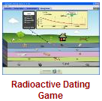
Intro to Half-Life PhET Lab (Radioactive Dating Game)
Introduction: Dead things decay into simpler molecules. Radioactive particles decay. Is it the same kind of decay? What does it mean when a substance is radioactive? In this simulation, you will investigate the concept of half-life.
Some handy vocabulary for you to define: (use your notes, your book, or the internet)
Neutron _______________________________________________________________________________________________
Isotope _______________________________________________________________________________________________
Radiocarbon Dating______________________________________________________________________________________
Half-Life _______________________________________________________________________________________________
Decay (as used in half-life)_________________________________________________________________________________
Carbon-14…what does the “14” represent? ___________________________________________________________________
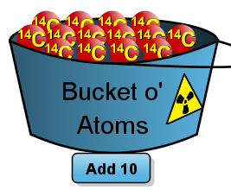
Procedure: PhETPlay with the Sims Chemistry Radioactive Dating Game
- Take some time and play with the simulation. Those atoms are radioactive! How cool is that?!
- How many protons does Carbon-14 have? _____________ (hint…what is its atomic number?)
- How many neutrons does Carbon-14 have? _____________ (hint: what is the mass?)
- Add a Carbon-14 atom to the play area. What happens to that Carbon-14 atom? ________________________________________________________________________________
- Do all Carbon-14’s decay at the same time? ____________________________________________
- Add 50 Carbon-14s. (click  five times.) What happens? _______________________________________________
- and Using 20 Carbon-14s, draw the pie graph at the following time periods:
5000 Years | 10000 years | 15000 years

- Redo the above with 100 Carbon-14 atoms and fill in the three boxes below.
5000 Years | 10000 years | 15000 years
- How do the pie graphs of 20 atoms compare to those of 100 atoms? __________________________________________
- Generally, does the size of a radioactive sample affect half-life? __________ Why/Why not? _______________________
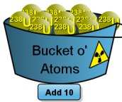
Consider Uranium-238...
- Carbon-14’s half-life was measured in thousands (5700) of years. About how long is Uranian-238’s half-life? _________________________________________________________________________
- How many protons does U-238 have? _____________ How many neutrons? __________________
- Into what atom does Uranium-238 decay? ______________________________________________

- Does the size of the sample of Uranium-238 affect its half-life? _______________________________________________
About that Unknown Element….
- How would you determine the half-life of this unknown element? Write up a little plan here:

- Estimate the half-life of this element. _________ seconds.

Observe the decay curves ( % remaining vs time) for Carbon-14 and Uranium-238. Sketch the decay curve for those isotopes here:
Uranium-238
Carbon-14

Determine how the little Geiger counter works in Measurement and Dating Game. Estimate the age of each of the following objects in the list below:
Item | Estimated Age | Item | Estimated Age
 |  | 
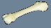 |  | 
 |  | 
Analysis questions
- Why can’t we use Carbon-14 to date the rocks? ___________________________________________________________
- Why couldn’t the fish fossil or dinosaur skull be dated with either C14 or U238? _________________________________
___________________________________________________________________________________________________
- Could Carbon-14 be used to date a hammer suspected of being used in 3400BC? _________ __________Why/Why not? ___________________________________________________________________________________________________
- The half-life of the unknown element was about _______ seconds.
- Starting with 100 Carbon-14 atoms, how many would you expect to have after one half-life? _____ After three? ______
- Make a small sketch of what a decay curve may look like for an unknown element
- You happen upon an antiques store and the clerk claims that he has a belt that was once worn by Alexander the Great, around 350 BC. You radiocarbon date it and find the percent of carbon to be 75% remaining. Could the belt be genuine?
How did you arrive at your answer?

