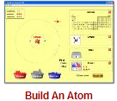
Build An Atom PhET Lab
Introduction: Atoms are the smallest things that retain the properties of matter we can observe. Atoms are made of three subatomic particles; protons, neutrons, and electrons.
- Protons have a mass of ___________ unit and a charge of ___________.
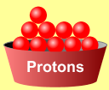
- Neutrons have a mass of ___________ unit and a charge of ___________.
- Electrons have a mass of nearly___________ unit and a charge of ___________.
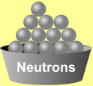
In this simulation, you will build atoms, subatomic particle by subatomic particle and observe the effect of adding more of each particle. When the subatomic particles in an atom change, an ion, isotope or different element will be created.
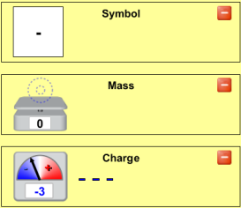
Procedure: Play with the Sims Chemistry Build An Atom
Begin by playing with the simulation for a while. Become familiar with the interface. What happens when you add protons, neutrons, or electrons? To start over, click .
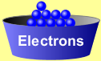
Show the symbol, atomic mass, and charge by clicking on the .
Analysis Questions
- Ions are atoms of the same element with different numbers of __________________.
- Isotopes are atoms of the same element with different numbers of __________________.
- Adding or removing protons from an atom does what to the atom? _________________________________.
- An atom with the same number of protons and electrons has a charge of _________.
- Adding two electrons to a neutral atom produces an ion with a charge of _________.
- An atom with six protons and five electrons would have a charge of _________.
- What atom is created with nine protons, nine neutrons, and nine electrons?
- Show the full symbol for the above atom in the box at the right
- What does the upper-left number in the symbol represent? __________________
- What does the lower-left number in the symbol represent? __________________
- Draw the atoms described below, showing protons, neutrons, and electrons:
Hydrogen: H Carbon: C Oxygen: O Neon: Ne

The Game
With remaining class time, play a few games. Who in your lab group can get the highest score? WINNER: _______________
Complete the table below
Remember…when there are more electrons than protons, the charge should be: _______________________.
And when there are more protons than electrons, the charge will be: _____________________.
Protons | Neutrons | Electrons | Atomic Number | Mass Number | Charge | Element | Full Symbol
4 | 4 | 4 | 4 | 8 | 0 | Be
5 | 5 | 6 | 1. | 2. | 3. | 4. | 5.
8 | 8 | 7 | 6. | 7. | 8. | 9. | 10.
11. | 12. | 13. | 7 | 13 | -3 | 14. | 15.
16. | 17. | 18. | 9 | 20 | -1 | 19. | 20.
Conclusion Questions (use a periodic table)
- All Zinc atoms have (how many?) _______ protons.
- If a Copper atom has no charge (neutral), it would contain (how many?) _______ electrons.
- All atoms that have 14 protons are (what element?) _____________.
- If an atom of Zinc has a mass of 64, it has (how many?) _______ neutrons.
- Silver-108 has a mass of 108. This means that it would have (how many?) _______ neutrons with its 47 protons.
- (Sodium) has (how many?) _______ protons and (how many?) _______ neutrons for a total mass of 23.
- A -1 ion of Bromine would have _______ protons and _______ electrons.
- A +2 ion of Calcium would have _______ protons and _______ electrons.
- To form an ion with a -2 charge, an atom of Sulfur would need to have _______ electrons.
- A neutral atom of Zinc-66 has _______ protons, _______ neutrons, and _______ electrons.

