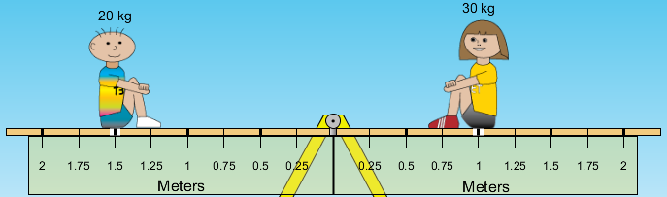
Name: _________________________
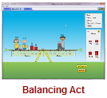
Balancing Act PhET Lab (2012)
Introduction: Ever had to carry a single heavy sack of books or groceries with one hand? What happens to your body to allow you to do this? How is your body different when you have to carry TWO sacks, one on each side?
How about the classic, teeter totter? Can your successfully totter with someone heavier than you? How? Many people think that weight is all that matters when you balance something but you know that downward force is only a part of the situation.
Some handy vocabulary for you to define:
Force: _______________________________________________________________________________________
Lever Arm: ___________________________________________________________________________________
Torque: ______________________________________________________________________________________
Fulcrum: _____________________________________________________________________________________
Equilibrium: __________________________________________________________________________________
Procedure: Play with the Sims Physics Motion Balancing Act
Take some time to play with the simulation. Go ahead. Play. Have fun. Learn. Are you still reading this?
Observe the following situations below and draw your prediction of what would be needed to bring all the objects into equilibrium. Test your prediction in the simulation.
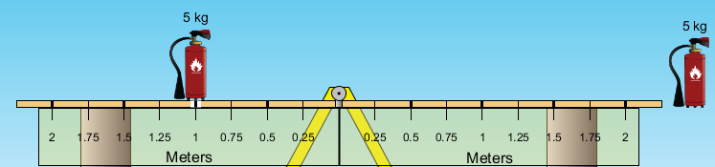
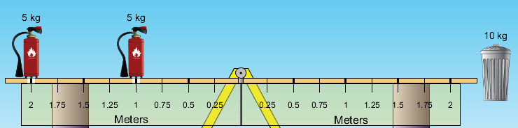
The next few require you to do a little more math…
Calculate exactly where the floating object should be placed to assure all objects are in equilibrium. Show your work below each drawing. You may check your work in the simulation AFTER calculations.
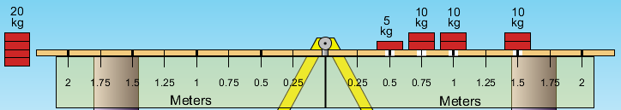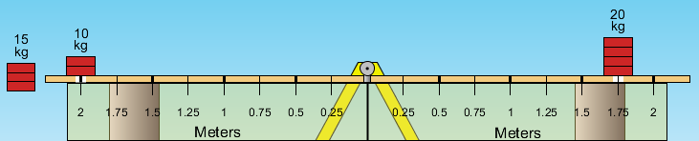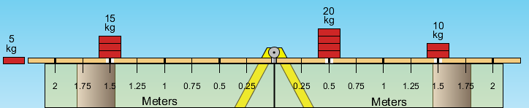
Show your work here. Remember units!
Show your work here. Remember units!
Show your work here. Remember units!
Finally, determine the mass of each of the mystery objects. (graded) (use scratch paper and as usual, do your own work)
 | 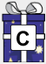 |  | 
 |  |  | 

