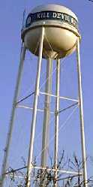
Bernoulli’s Continuity of Fluid Pressure PhET Lab (TWO DAYS)
Introduction:
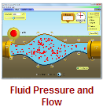

We’ve all put our thumbs over a hose to get that extra oomph out of a garden hose. Why does the water speed up? Why do some towns have water towers, giant tanks of water suspended high above the town? Why does your face turn red when you do a handstand? This simulation will help you answer these and other important questions about fluids and pressure.
Critical to the understanding of fluids and pressure is the idea that liquids are incompressible, that is, that you can’t get them to squish and compress like a gas. In other words, when liquids move, the same amount goes in as comes out. This principle was an important part of Daniel Bernoulli’s work into fluid dynamics, how a fluid changes (or doesn’t change) as it moves. The individual parts of the formulas related to the continuity of fluid flow can be summarized in what many of us call Bernoulli’s Equations:


Please take some time to define the each of the variables present in the above equations:
P ______________________________________________________ units of: ____________________
ρ (rho) _________________________________________________ units of: _____________________
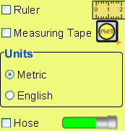
v ______________________________________________________ units of: _____________
g ______________________________________________________ units of: _____________
h ______________________________________________________ units of: _____________
A ______________________________________________________units of: _____________

Procedure: PhET Simulations Play With Sims Physics Fluid Pressure and Flow
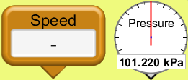
- Take some time and play with the simulation. Answer the questions below as you play. Learn how to use the toolkit on the left; these tools will be very useful in this simulation.

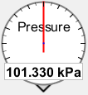
As the sensor is moved deeper into the liquid, how does the pressure change? _______________________________
_____________________________________________________________________________________________

As more liquid is added, how does the pressure near the bottom of the tank change? ________________________
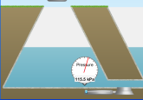
Why does the pressure change as the sensor is moved up and down in the air above the liquid? ______________
__________________________________________________________________________________________


How does the pressure in the water change when the atmosphere is removed? __________________________

Why is this? ______________________________________________________________________________
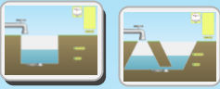
Does the shape of the tank play a role in the pressure under the surface? __________________________

Why do you suppose this is? _____________________________________________________________

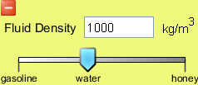
How does the density of the fluid relate to the pressure it exerts? _________________________________
______________________________________________________________________________________

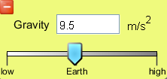
How does increasing gravity change the pressure in the fluid?____________________________________

Why do you think this is? _________________________________________________________________

At normal Earth gravity (9.8 m/s²), how does pressure (in Pascals, Pa) change for each meter of water depth? ____________Pa
To what depth would you have to swim to experience another “atmosphere” (+101000 Pa)? _______________m

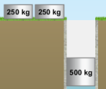
Why does adding a floating mass appear to change the pressure of the liquid? ____________________________

What is the floating mass changing? _____________________________________________________________
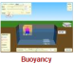
What effect does changing the density of the liquid have on the buoyant force applied on the floating mass? ___________________________________________________________________________________________

Imagine the following as pipes carrying water. How would the speed and pressure of the water in the center of the pipe change as it moves from left to right? Speed? Pressure?

1.

2.

3.

4.

5.

6.

7.

8.

How does flow rate (volume per second) change as a pipe becomes smaller (as in #3)? ________________________________
How does the flow rate (volume per second) change as a pipe rises (as in #2)? ______________________________________
Explain your answers to the two questions above. ______________________________________________________________
If one trillion water molecules are added to one end of a filled garden hose, what happens at the other end of the garden hose?
______________________________________________________________________________________________________
As fluid density increases, the fluid speed (increases / decrease / remains the same) and the pressure (increases / decreases remains the same). Explain your answers. ___________________________________________________________________
Imagine two identical houses, one at the top of a hill and one at the bottom of a valley. In which one would you rather take a shower? ___________________ Why? ______________________________________________________________________
Shower pipes in newer houses have smaller diameters than those in older houses. Why do you suppose this is? ____________
______________________________________________________________________________________________________
Using the formulas on the front page, calculate this: water flows horizontally through a garden hose with an inner diameter of .012 m at a speed of 7.8 m/s. It exits out a small nozzle with a diameter of only 0.0085 m. How fast it is travelling out of the nozzle? _____________________ m/s
Kinematics formulas you may use:

In this simulation, water is allowed to flow out of a hole at the bottom of a tall water tower. Play with the simulation and use the tools provided before answering the questions below. When allowing fluid out, assume tank is FILLED.
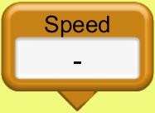
Does the speed of the flow of the water (out of the tank) depend upon the height of the tank? _______________
Why do you suppose this is? __________________________________________________________________
Does the speed of the flow depend upon the fluid density? __________________________________________
What does flow speed depend upon? ________________________________________________________________________
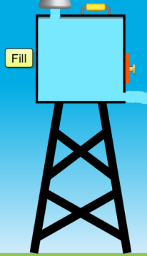
Explain this relationship (in your own words). ________________________________________________________________

What happens to the stream of fluid after it leaves the tank? ________________________________________
Describe the path of the fluid steam. __________________________________________________________
Does it remind you of anything you have seen before (in physics, not in the bathroom)? _________________
What does it remind you of? _________________________________________________________________
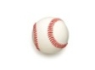
How far (horizontally) will a steam of water travel if it exists the water tower at 14 m/s 10m above the ground? ______________________________________________________________
How far do you suppose a baseball will travel if thrown horizontally 14 m/s from the top of a 10m-high ladder? ____________

Turn on the hose and leave it aimed directly upward. Adjust the other pieces of the simulation. What do you notice about the height of the little fountain created?
______________________________________________________________________________________________________
When you have your blood pressure monitored, the nurse places the cuff on your arm, just below the shoulder. Why do you suppose this is? _________________________________________________________________________________________
What organ is s/he really measuring? ________________________________________________________________________
The height difference between the top of the tower and the leaking hole is 10 m. Using the Bernoulli’s big ol’ continuity formula, to what depth would the tower need to be filled to produce a stream leaving the hole at 8.0 m/s? _________________
As the stream falls it gains speed. Why is this? _______________________________________________________________

Conclusion Questions and Calculations (please attach scratch paper with your calculations when appropriate)
Static Pressure at Depth
- Does air produce a pressure? (Yes, air is a fluid. / No. Air is not dense enough to exert pressure)
- As I swim deeper in a pool, the pressure on me (increases / decreases).
- If I replaced all the water in my swimming pool with honey, the pressure at the bottom of the pool would (increase / decrease).
- If the pressure at San Francisco’s Pier 39 (sea level) is 101kPa, you would expect the pressure at Las Vegas’ strip (620 m or 2030 ft above sea level) to be (higher than 101kPa / the same 101kPA / lower than 101kPa)
- For every meter of depth in water (density = 1000 kg/m³) what is the increase in pressure? _________________ Pa
- If the pressure above the surface of a swimming pool is 101000 Pa, what pressure will you experience 4.4 meters below the surface? _____________________ Pa
A
B
- Consider the diagram here of a weird sort of swimming pool.
Pressure is greatest at __________
C
D
Pressure is least at __________
F
Two points where pressure is the same __________
E
Flowing Fluids (horizontally)
- If 40 L of water enter a garden hose each minute, we would expect how much water to exit the hose each second? _______
- When water flows downhill as in (Flow Arrow #1), we expect the pressure to (increase / decrease / remain the same).
- As a hose’s cross sectional area becomes smaller (hose being squished) we would expect the pressure of the fluid at the squish to (increase / decrease / remain the same).
- As a hose’s cross sectional area becomes smaller (hose being squished) we would expect the speed of the fluid at the squish to (increase / decrease / remain the same).
- As a hose’s cross sectional area becomes smaller (hose being squished) we would expect the flow rate (volume per second) at the squish to (increase / decrease / remain the same).
- If we replace the water in our hypothetical hose with honey and using the same flow rate as before, we would expect the pressure to (increase / decrease / remain the same). (ignore friction/viscosity)
- The speed of the more-dense honey, compared to the water in the same hose would be (faster / slower / the same speed).
- Imagine water flowing in a stream with a diameter of 1.5m at a speed of 6.8 m/s. If a rock blocked half of the stream, how fast would the water flow around the rock?
____________________m/s
- If the stream (back to its 1.5m diameter and 6.8 m/s speed) flowed downhill 18 meters, how fast would we expect it to flow?
____________________m/s
Flowing Fluids (as projectiles)
- Are fluids (liquids and gasses) affected by gravity? (Yes, even air gets pulled down by gravity / No. Air is not dense enough to be affected by gravity)
- Remembering your kinematics of projectiles…A baseball is thrown horizontally a 25 m/s from the top of a 5m-high tower. How far does it travel?
____________________m
- If a stream of water exits a water tower horizontally with a speed of 25 m/s 5m above the ground, we would expect it to travel how far?
____________________m
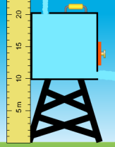
- Consider a water tower like the one pictured at the introduction of this lab. Imagine a 10-meter tall water tower develops a small hole at its base, 10 meters above the ground. If the water tower is open to the atmosphere at the top and at the hole, how fast (speed, not time) would the water leak out of the hole? ____________________m/s

- Now, using what you’ve learned about kinematics, if the hole created a horizontal stream, how far from the base of the water tower would the water initially land?

____________________m
- As the water leaked out over time, would the stream of water travel further from the base, closer to the base, or remain the same distance from the base? ________________________
- Why is this? ________________________________________________________________________________________
- How deep would the water have to be to create a stream leaking out at 12.0 m/s?
____________________m

- Consider this: a 2L soda bottle can take about 5 atmospheres of pressure before it bursts. This is 505000Pa! If you attach a steel pipe (vertically) to the bottle and fill that bottle/pipe system with water (density = 1000 kg/m³) there is a height where the pressure of the column of water will cause the bottle to rupture. What is that height?
____________________m

- How high could a similar bottle hold a column of honey (density = 1420 kg/m³)?
____________________m
- If you tried this investigation using PVC pipe rated to fail at pressures exceeding 60 PSI, which would rupture first, the PVC pipe or the plastic 2L bottle? (look up pressure values) ____________________

