
Trig Tour – Seeing Patterns in a Unit Circle
PRE-PLANNING | PRIOR KNOWLEDGE
PRE-PLANNING | - Know the trigonometric functions of Sine, Cosine and Tangent  - Use Pythagorean Theorem to find the missing side of a right triangle  - Use knowledge about 45-45-90 and 30-60-90 triangles to quickly find missing sides  - Graph on a Cartesian coordinate system
PRE-PLANNING | LEARNING GOALS
PRE-PLANNING | - Associate the coordinates of points on the circumference of the unit circle with the cos and sin of the angle made by the radius containing these points, with the positive direction of the x-axis  - Easily translate between multiple representations of trig functions: as sides of a right triangle inscribed in a unit circle, and numerical values of function.  - Deduce the sign (+, -, 0) of trig function for any given angle without a calculator using the unit circle concept.  - Define exact trig functions for special angles using degrees or radians for angle measures.
PRE-PLANNING | Common Core Standards | Common Core Practices
PRE-PLANNING | CCSS.Math.Content.HSG.SRT.C.8  Use trigonometric ratios and the Pythagorean Theorem to solve right triangles in applied problems.  CCSS.Math.Content.HSF.TF.A.3  (+) Use special triangles to determine geometrically the values of sine, cosine, tangent for π/3, π/4 and π/6, and use the unit circle to express the values of sine, cosine, and tangent for x, π + x, and 2π - x in terms of their values for x, where x is any real number. | 2. Reason abstractly and quantitatively  7. Look for and make use of structure
PRE-PLANNING | MATERIALS
PRE-PLANNING | PhET Trig Tour simulation: http://phet.colorado.edu/sims/html/trig-tour/latest/trig-tour_en.html  - Laptop/Chromebook/tablet for each student or pair  - Seating chart that allows for occasional pairings of students.  - “Trig Tours” Activity Sheet for each student (see below)
LESSON CYCLE | Connect 8 minutes
LESSON CYCLE | - Hand out the Part 1 Connect worksheet.  - Ask students to work with a partner to complete the review.  - Use a document camera to share student work, or have students write their work on the board.
LESSON CYCLE | Explore the Sim 5 minutes
LESSON CYCLE | Ask the students to access the PhET Trig Tours Simulation here:  http://phet.colorado.edu/sims/html/trig-tour/latest/trig-tour_en.html  Allow students 5 minutes to explore the sim. You can provide the PART II – EXPLORE handout to students to complete, or use that handout as questions to ask students as you walk around.  - As a whole class, provide students with time to share what they learned about the sim, especially pointing out features of the sim’s controls, and connecting the special angles to the triangle problems they just solved.
LESSON CYCLE | Investigate Relationships 15 minutes
LESSON CYCLE | Pass out the worksheet PART III to the students. Have the students work independently or in pairs to answer the questions.  Circulate the room to be available for student questions and to ask probing/pushing questions. If a student is struggling with the task, it can help to probe for more information.  - What do you see on the unit circle?  - What angle is being considered? How do you know?  - Where will sin be positive?  - Where will sin be negative?  - Where will cos be positive? When will cos negative? How do you know?  - Can you predict for a particular angle whether the sin is positive or negative? How?  BE SURE:  To check to see that students are seeing patterns in the ordered pairs of the unit circle.
LESSON CYCLE | Discuss 15 minutes
LESSON CYCLE | - Remind students to close their laptops or turn around so that the sim does not distract them from listening.  - Use an established teaching strategy such as popcorn discussion (one student answers, calls on the next student to talk), think-pair-share (pose question, allow time to think, turn and talk to partner), or group discussions (print out questions and have groups talk to each other and write down consensus to share aloud with class). Sample questions include:  - What patterns did you find?  - How do these patterns help you know if the sin or cos will be positive or negative without using this sim?  - What strategies might help students remember the values of the unit circle?  - Why did knowing the special triangles help in finding the ordered pairs of the unit circle?  - Why is it called a unit circle?
LESSON CYCLE | Closure 10 minutes
LESSON CYCLE | - Have students use their completed unit circle to quickly find the sin and cos of a variety of angles (both in degrees and radians).  - Your students may find the ‘finger trick’ to be a fun way to remember the values. You can learn more about it here: http://www.moomoomath.com/Easy-way-Learn-Unit-Circle.html

 Trig Tour – Seeing Patterns in a Unit Circle
Part I – Connect
We learned about short cuts that help us to quickly find the lengths of the sides of a couple of special right angles.

For example, in a 45-45-90 triangle, the two sides of the triangle are equal. Sketch a 45-45-90 triangle with a hypotenuse of 1. Find the missing sides.

A second short cut helps us to quickly find the sides of another special right angle, the 30-60-90 triangle.

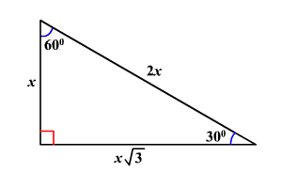

If the hypotenuse is 1, what are the lengths of the other two sides?

Trig Tour – Seeing Patterns in a Unit Circle
Part II – Explore
Explore Trig Tour for five minutes. Try to figure out what’s going on.
Click on the Special Angles button. What angles are included?

How are the angles measured?

Look at the values of SIN as you move the red dot. What do you notice?

Look at the values of COS as you move the red dot. What do you notice?

What is the unit size of each line? How do you know?

What is the radius of the circle? How do you know?

At the end of the five minutes, you’ll be asked to share what you’ve noticed with your partner and then with the class.
Trig Tour – Seeing Patterns in a Unit Circle
Part III – Investigate
Click on the special angles button.
Sketch and label the sides of each triangle in the first quadrant. Then find the basic trig functions of the triangle. Next, find the ordered pair where the triangle touches the circumference. Finally, find the angle size. The first one is done for you.

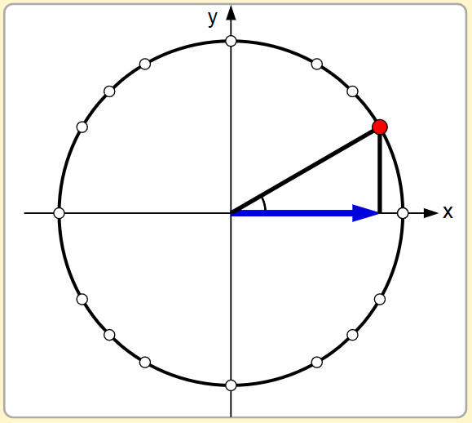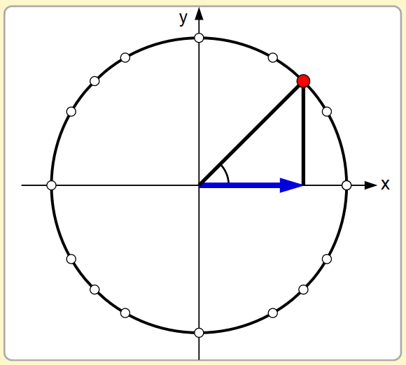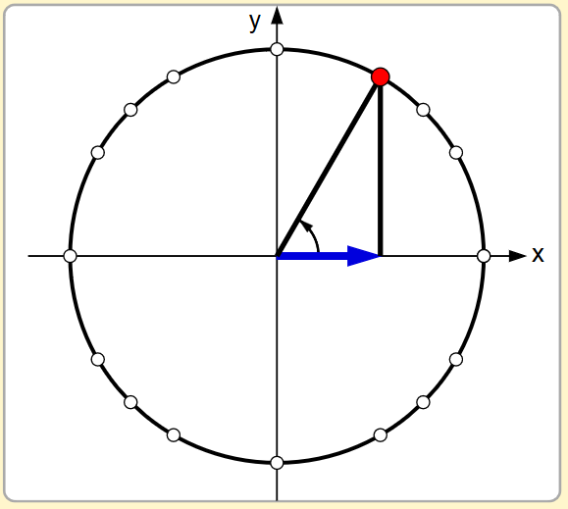

Sin: ½
Cos: $\frac{\sqrt{3}}{2}$
Tan:$\frac{1}{2}÷\frac{\sqrt{3}}{2}=\frac{1}{2}∙\frac{2}{\sqrt{3}}=\frac{1}{\sqrt{3}}∙\frac{\sqrt{3}}{\sqrt{3}}=\frac{\sqrt{3}}{3}$
Ordered Pair: $\left(\frac{\sqrt{3}}{2},\frac{1}{2}\right)$
Angle: 30° or $\frac{π}{6}$ radians

$$\frac{\sqrt{3}}{2}$$
½
1
Repeat for the angles in Quadrant II. Sketch and label the sides of each triangle in the first quadrant. Then find the basic trig functions of the triangle. Finally, find the ordered pair where the triangle touches the circumference.

Compare your answers from the two different quadrants. What do you notice?

Make a prediction for quadrants III and IV. Then complete the same steps as above to check your answers.

Quadrant III
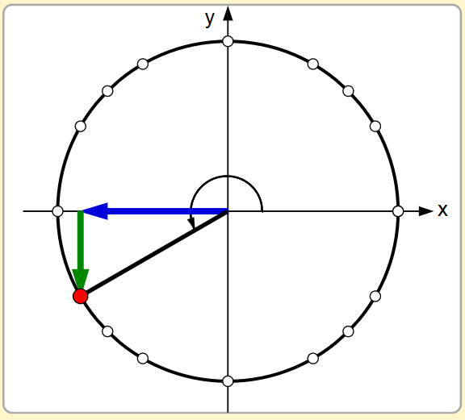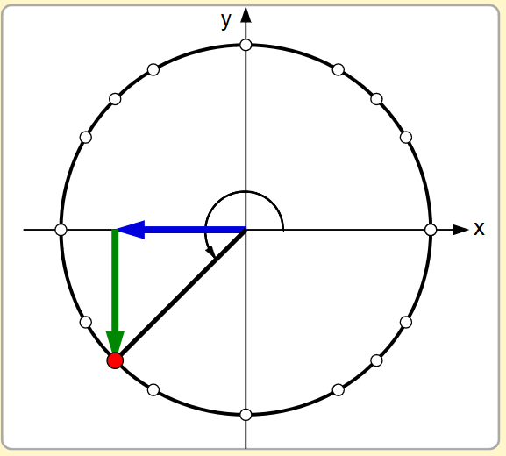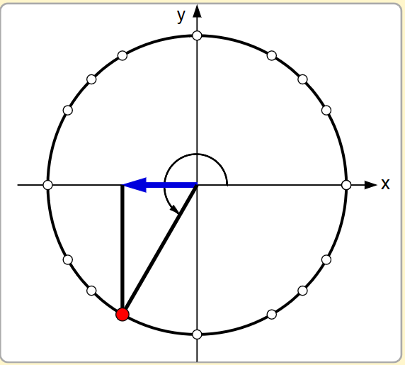

Quadrant IV

Look back on your work:
What is the relationship between sin θ and the ordered pair where the triangle touches the circumference of the circle?

What is the relationship between cos θ and the ordered pair where the triangle touches the circumference of the circle?

Look for patterns in the answers above, and then use what you know to answer the following questions:
What is sin 90°? What is cos 90°?

What is sin 0°? What is cos 0°?

What is sin 180°? What is cos 180°?

What is sin 270°? What is cos 270°?

In which quadrants will sin θ be positive?
In which quadrants will sin θ be negative?
In which quadrants will cos θ be positive?
In which quadrants will cos θ be negative?
In which quadrants will tan θ be positive?
In which quadrants will tan θ be negative?

Using your data that you’ve created, add the following to this picture:
- ordered pairs for each point on the circle
- degrees of the angle associated with that point
- radians of the angle associated with that point
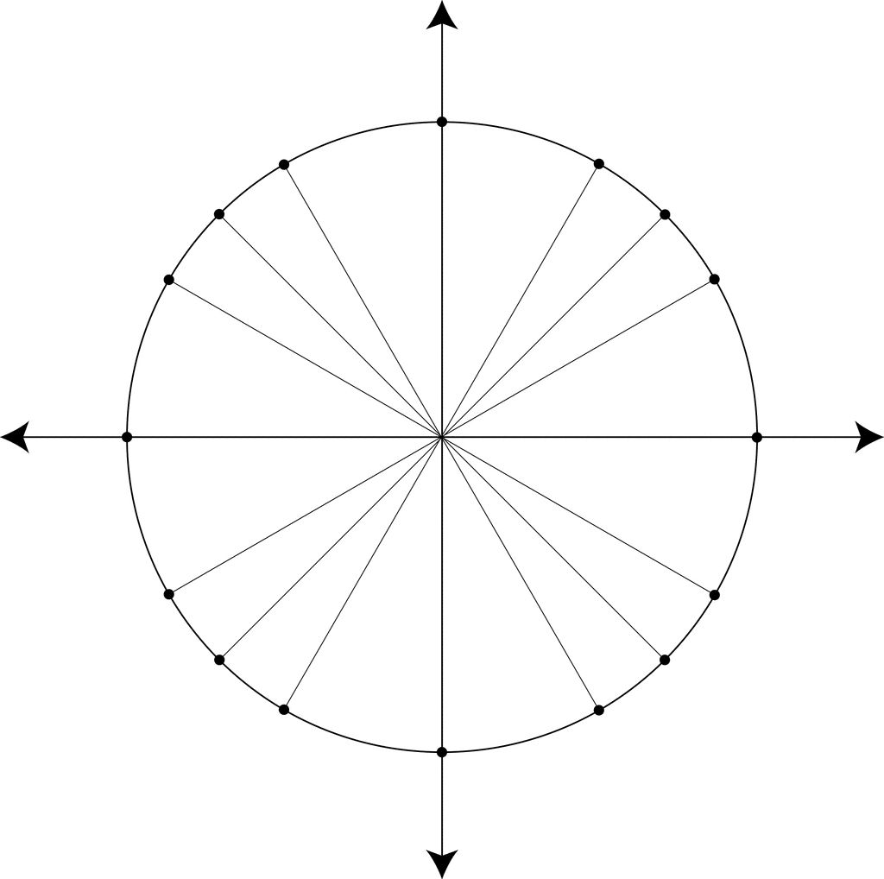
Trig Tour – Seeing Patterns in a Unit Circle
$$\left(\frac{\sqrt{3}}{2},\frac{1}{2}\right)$$
30° $\frac{π}{6}$
Part I – Connect - ANSWERS
We learned about short cuts that help us to quickly find the lengths of the sides of a couple of special right angles.

For example, in a 45-45-90 triangle, the two sides of the triangle are equal. Sketch a 45-45-90 triangle with a hypotenuse of 1. Find the missing sides.

x² + x² = 1²
2x² = 1
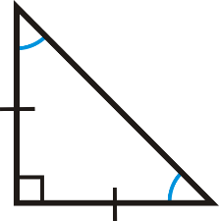
x² = ½
x
1
$\sqrt{x^{2}}= \sqrt{\frac{1}{2}}$

$x= \sqrt{\frac{1}{2}}= \frac{\sqrt{2}}{2}$
x

A second short cut helps us to quickly find the sides of another special right angle, the 30-60-90 triangle.

If the hypotenuse is 1, what are the lengths of the other two sides?

1
$\frac{1}{2}$
$$\frac{\sqrt{3}}{2}$$

Trig Tour – Seeing Patterns in a Unit Circle
Part II – Explore - ANSWERS
Explore Trig Tour for five minutes. Try to figure out what’s going on.
Click on the Special Angles button. What angles are included?
0 - 30 – 45 – 60 – 90 – 120 – 135 – 150 – 180 – 210 – 225 – 240 – 270 – 300 – 315 – 330 - 360
Where did they start measuring the angles from?
Possible student answers:
All the angles are measured from the center right of the circle

Look at the values of SIN as you move the red dot. What do you notice?
Possible student answers:
The sin values are the same on the left and right of the circle
The sin values are the opposite signs on the top and bottom of the circle

Look at the values of COS as you move the red dot. What do you notice?
Possible student answers:
The cos values are the same on the top and bottom of the circle
The cos values are the opposite signs on the left and right of the circle

What is the unit size of each line? How do you know?
Possible student answers:
Each line is ½ of a unit. Two sections equal one unit.

What is the radius of the circle? How do you know?
Possible student answers:
The radius is 1 unit. You can see this when labels are turned on.

At the end of the five minutes, you’ll be asked to share what you’ve noticed with your partner and then with the class.
Trig Tour – Seeing Patterns in a Unit Circle
Part III – Investigate - ANSWERS
Click on the special angles button.
Sketch and label the sides of each triangle in the first quadrant. Then find the basic trig functions of the triangle. Next, find the ordered pair where the triangle touches the circumference. Finally, find the angle size. The first one is done for you.

1
$$\frac{\sqrt{2}}{2}$$
$$\frac{\sqrt{2}}{2}$$
½
$$\frac{\sqrt{3}}{2}$$
1

Sin: $\frac{\sqrt{3}}{2}$
Cos: ½
Tan:$\frac{\sqrt{3}}{2}÷\frac{1}{2}=\frac{\sqrt{3}}{2}∙\frac{2}{1}=\frac{\sqrt{3}}{1}=\sqrt{3}$
Ordered Pair: $\left(\frac{1}{2},\frac{\sqrt{3}}{2}\right)$
Angle: 60° or $\frac{π}{3}$ radians

Sin: $\frac{\sqrt{2}}{2}$
Cos: $\frac{\sqrt{2}}{2}$
Tan:$\frac{\sqrt{2}}{2}÷\frac{\sqrt{2}}{2}=\frac{\sqrt{2}}{2}∙\frac{2}{\sqrt{2}}=\frac{2\sqrt{2}}{2\sqrt{2}}=1$
Ordered Pair: $\left(\frac{\sqrt{2}}{2},\frac{\sqrt{2}}{2}\right)$
Angle: 45° or $\frac{π}{4}$ radians

Sin: ½
Cos: $\frac{\sqrt{3}}{2}$
Tan:$\frac{1}{2}÷\frac{\sqrt{3}}{2}=\frac{1}{2}∙\frac{2}{\sqrt{3}}=\frac{1}{\sqrt{3}}∙\frac{\sqrt{3}}{\sqrt{3}}=\frac{\sqrt{3}}{3}$
Ordered Pair: $\left(\frac{\sqrt{3}}{2},\frac{1}{2}\right)$
Angle: 30° or $\frac{π}{6}$ radians

$$\frac{\sqrt{3}}{2}$$
½
1
Repeat for the angles in Quadrant II. Sketch and label the sides of each triangle in the first quadrant. Then find the basic trig functions of the triangle. Finally, find the ordered pair where the triangle touches the circumference.

½

Sin: $\frac{\sqrt{3}}{2}$
Cos: -½
Tan:
$$\frac{\sqrt{3}}{2}÷-\frac{1}{2}=\frac{\sqrt{3}}{2}∙\frac{2}{1}=-\frac{\sqrt{3}}{1}=-\sqrt{3}$$
Ordered Pair: $\left(-\frac{1}{2},\frac{\sqrt{3}}{2}\right)$
Angle: 120° or $\frac{2π}{3}$ radians

1

Sin: ½
Cos:- $\frac{\sqrt{3}}{2}$
Tan:
$$\frac{1}{2}÷-\frac{\sqrt{3}}{2}=\frac{1}{2}∙-\frac{2}{\sqrt{3}}=-\frac{1}{\sqrt{3}}∙\frac{\sqrt{3}}{\sqrt{3}}=-\frac{\sqrt{3}}{3}$$
Ordered Pair: $\left(-\frac{\sqrt{3}}{2},\frac{1}{2}\right)$
Angle: 150° or $\frac{5π}{6}$ radians

Sin: $\frac{\sqrt{2}}{2}$
Cos: -$\frac{\sqrt{2}}{2}$
Tan:
$$\frac{\sqrt{2}}{2}÷-\frac{\sqrt{2}}{2}=\frac{\sqrt{2}}{2}∙-\frac{2}{\sqrt{2}}=-\frac{2\sqrt{2}}{2\sqrt{2}}=-1$$
Ordered Pair: $\left(-\frac{\sqrt{2}}{2},\frac{\sqrt{2}}{2}\right)$
Angle: 135° or $\frac{3π}{4}$ radians

$$\frac{\sqrt{3}}{2}$$
$$\frac{\sqrt{2}}{2}$$
1
1
$$\frac{\sqrt{3}}{2}$$
$$\frac{\sqrt{2}}{2}$$
½

Compare your answers from the two different quadrants. What do you notice?
Possible student answer
The sins are the same value, the cosines are the opposite sign. For the ordered pairs, the x values changed signs while the y values stayed the same. The triangles are the same, just flipped.

Make a prediction for quadrants III and IV. Then complete the same steps as above to check your answers.

Quadrant III
Sin: $-\frac{\sqrt{2}}{2}$
Cos: $-\frac{\sqrt{2}}{2}$
Tan:$=1$Ordered Pair: $\left(-\frac{\sqrt{2}}{2},-\frac{\sqrt{2}}{2}\right)$
Angle: 225° or $\frac{5π}{4}$ radians
Sin: $-\frac{\sqrt{3}}{2}$
Cos: $-\frac{1}{2}$
Tan:$=\sqrt{3}$Ordered Pair: $\left(-\frac{1}{2},-\frac{\sqrt{3}}{2}\right)$
Angle: 240° or $\frac{4π}{3}$ radians
Sin: $-\frac{1}{2}$
Cos:- $\frac{\sqrt{3}}{2}$
Tan:$=\frac{\sqrt{3}}{3}$Ordered Pair: $\left(-\frac{\sqrt{3}}{2},-\frac{1}{2}\right)$
Angle: 210° or $\frac{7π}{6}$ radians

Quadrant IV
Sin: $-\frac{\sqrt{2}}{2}$
Cos: $\frac{\sqrt{2}}{2}$
Tan:$=-1$Ordered Pair: $\left(\frac{\sqrt{2}}{2},-\frac{\sqrt{2}}{2}\right)$
Angle: 315° or $\frac{7π}{4}$ radians
Sin: $-\frac{1}{2}$
Cos: $\frac{\sqrt{3}}{2}$
Tan:$=-\frac{\sqrt{3}}{3}$Ordered Pair: $\left(\frac{\sqrt{3}}{2},-\frac{1}{2}\right)$
Angle: 330° or $\frac{11π}{6}$ radians
Sin: $-\frac{\sqrt{3}}{2}$
Cos: $\frac{1}{2}$
Tan:$=-\sqrt{3}$Ordered Pair: $\left(\frac{1}{2},-\frac{\sqrt{3}}{2}\right)$
Angle: 300° or $\frac{5π}{3}$ radians
Look back on your work:
What is the relationship between sin θ and the ordered pair where the triangle touches the circumference of the circle?
Sin of the angle matches the y value of the ordered pair

What is the relationship between cos θ and the ordered pair where the triangle touches the circumference of the circle?
Cos of the angle matches the x value of the ordered pair

Look for patterns in the answers above, and then use what you know to answer the following questions:
What is sin 90°? 1 What is cos 90°? 0

What is sin 0°? 0 What is cos 0°? 1

What is sin 180°? 0 What is cos 180°? -1

What is sin 270°? -1 What is cos 270°? 0

In which quadrants will sin θ be positive? I, II
In which quadrants will sin θ be negative? III, IV
In which quadrants will cos θ be positive? I, IV
In which quadrants will cos θ be negative? II, III
In which quadrants will tan θ be positive? I, III
In which quadrants will tan θ be negative? II, IV

Using your data that you’ve created, add the following to this picture:
- ordered pairs for each point on the circle
- degrees of the angle associated with that point
- radians of the angle associated with that point
60° $\frac{π}{3}$

90° $\frac{π}{2}$

120° $\frac{2π}{3}$

300° $\frac{5π}{3}$

270° $\frac{3π}{2}$

$$\left(\frac{\sqrt{3}}{2},-\frac{1}{2}\right)$$
$$\left(-\frac{\sqrt{3}}{2},-\frac{1}{2}\right)$$
$$\left(-\frac{\sqrt{3}}{2},\frac{1}{2}\right)$$
$$\left(\frac{\sqrt{2}}{2},-\frac{\sqrt{2}}{2}\right)$$
$$\left(-\frac{\sqrt{2}}{2},-\frac{\sqrt{2}}{2}\right)$$
$$\left(-\frac{\sqrt{2}}{2},\frac{\sqrt{2}}{2}\right)$$
$$\left(\frac{\sqrt{2}}{2},\frac{\sqrt{2}}{2}\right)$$
$$\left(\frac{1}{2},-\frac{\sqrt{3}}{2}\right)$$
$$\left(-\frac{1}{2},-\frac{\sqrt{3}}{2}\right)$$
$$\left(-\frac{1}{2},\frac{\sqrt{3}}{2}\right)$$
$$\left(\frac{1}{2},\frac{\sqrt{3}}{2}\right)$$
240° $\frac{4π}{3}$

315° $\frac{7π}{4}$

30° $\frac{π}{6}$
330° $\frac{11π}{6}$

225° $\frac{5π}{4}$

210° $\frac{7π}{6}$

135° $\frac{3π}{4}$

45° $\frac{π}{4}$
150° $\frac{5π}{6}$

180° $π$

0° $2π$

$$\left(\frac{\sqrt{3}}{2},\frac{1}{2}\right)$$

