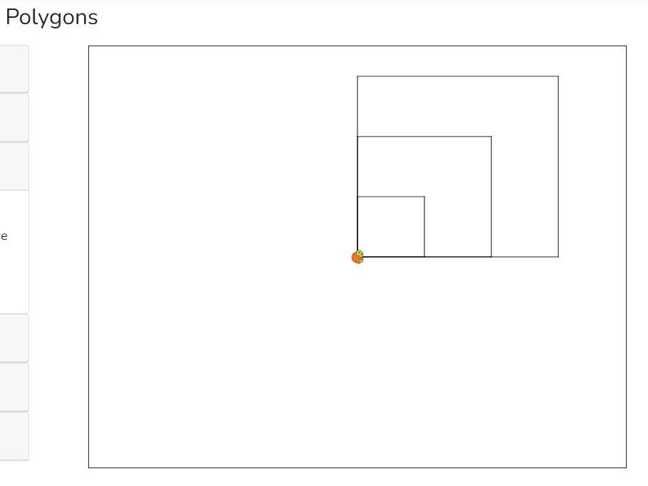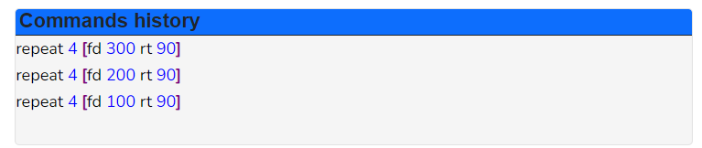

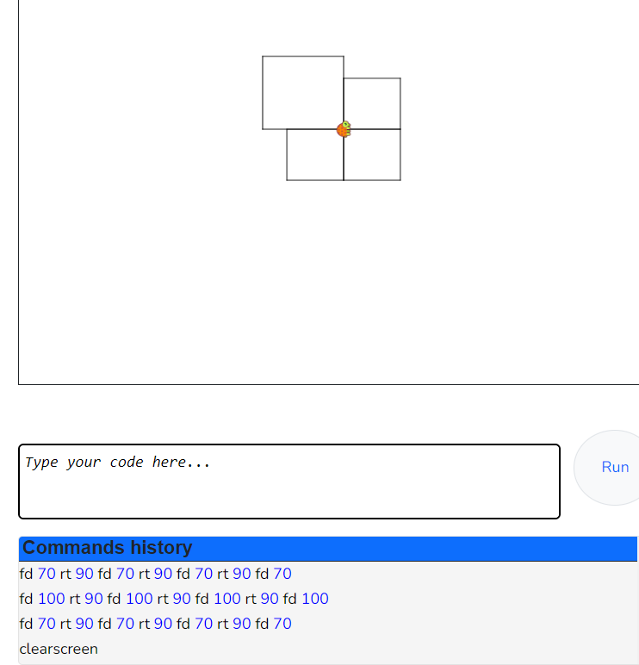
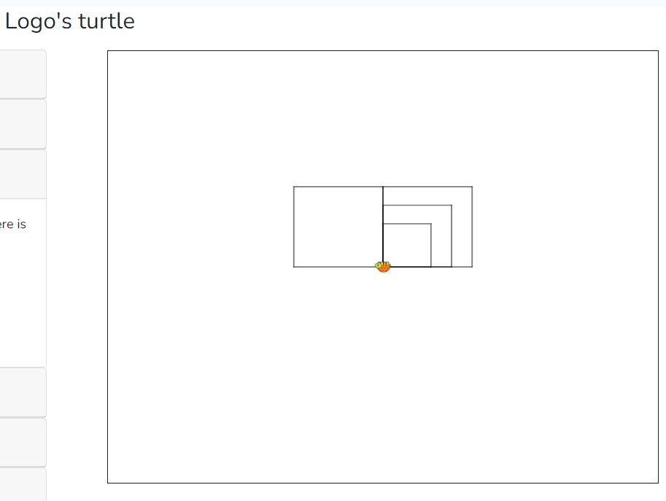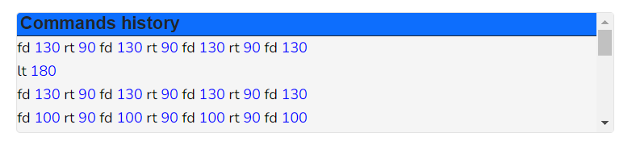
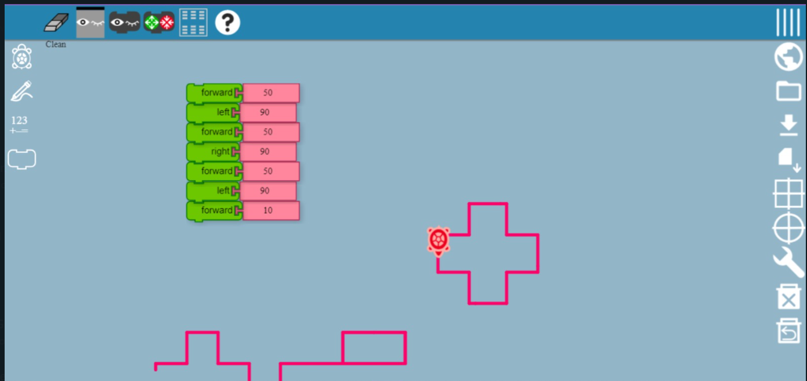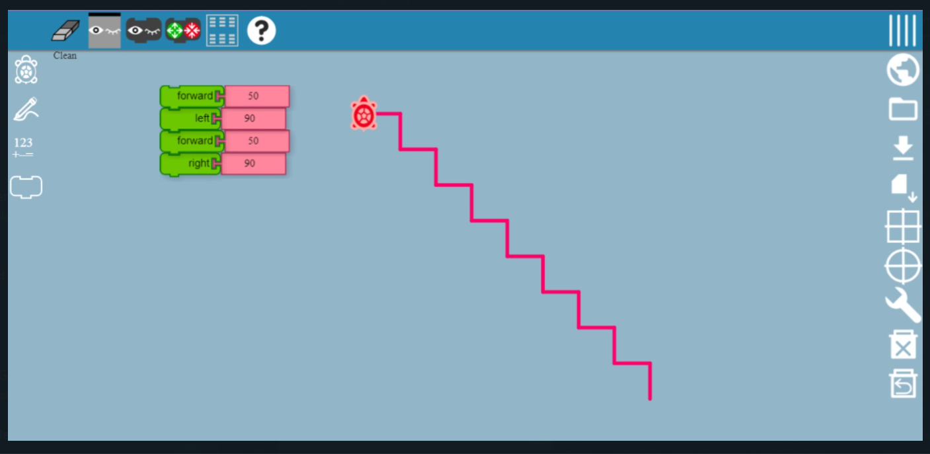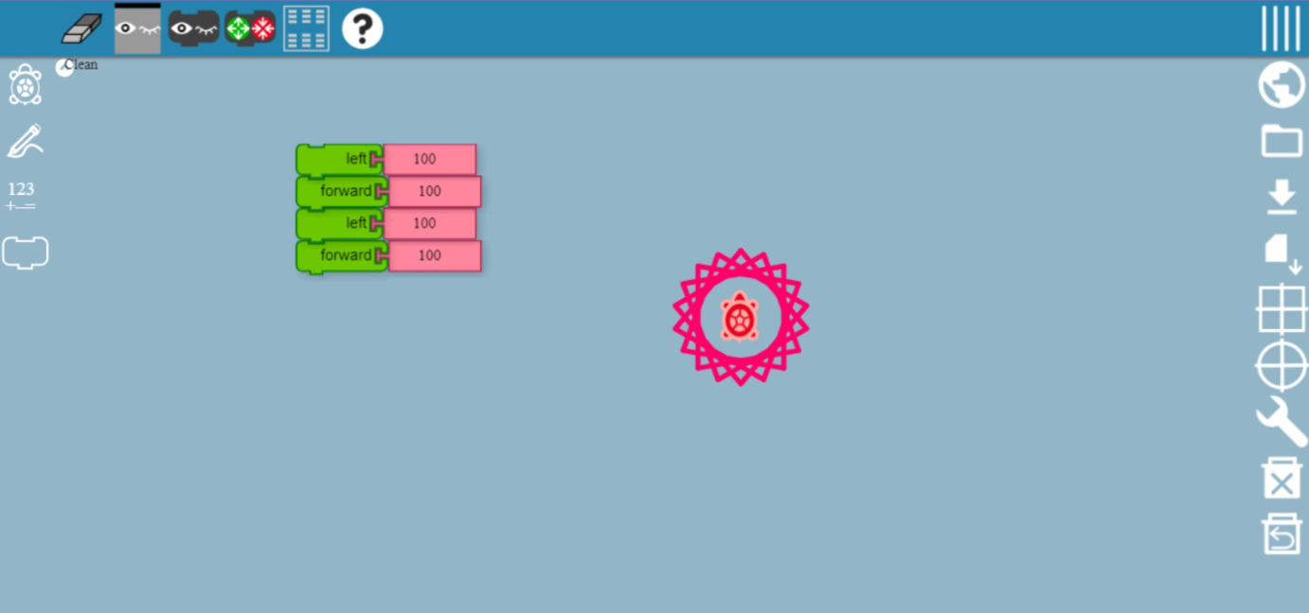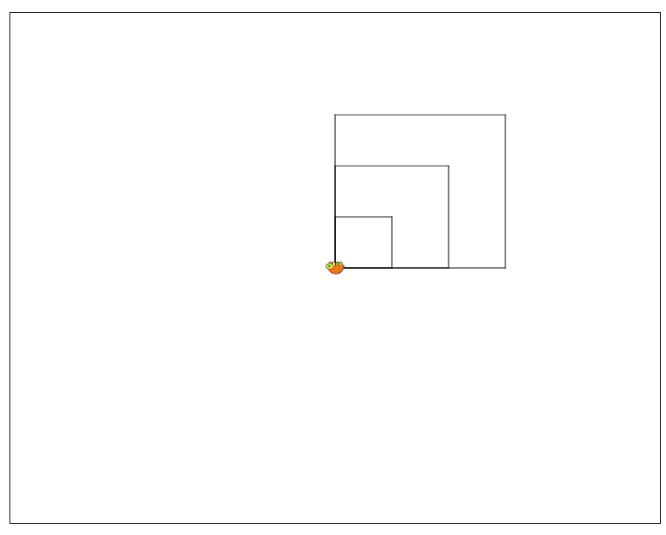
CODE:

fd 210 rt 90 fd 210 rt 90 fd 210 rt 90 fd 210
lt 180
lt 90
lt 180
fd 140 rt 90 fd 140 rt 90 fd 140 rt 90 fd 140
lt 180
lt 90
lt 180
fd 70 rt 90 fd 70 rt 90 fd 70 rt 90 fd 70
clearscreen
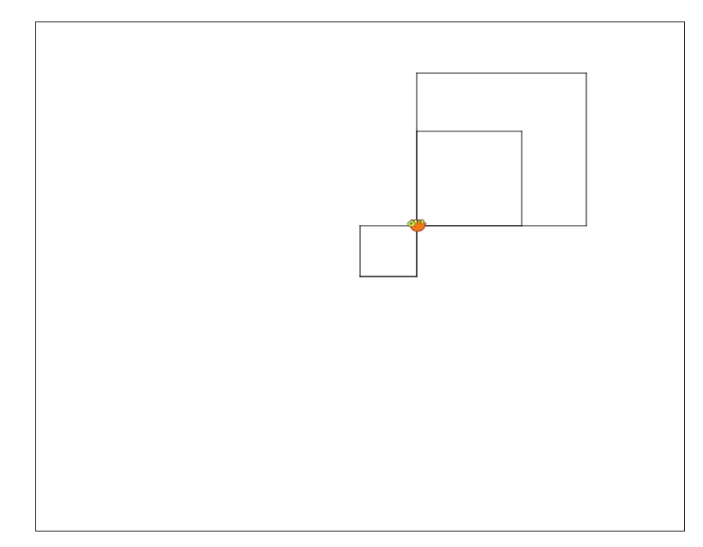

Commands history
fd 210 rt 90 fd 210 rt 90 fd 210 rt 90 fd 210
LT 90
lt 180
fd 130 rt 90 fd 130 rt 90 fd 130 rt 90 fd 130
FD 70
LT 90
FD 70
lt 180
fd 70 rt 90 fd 70 rt 90 fd 70 rt 90 fd 70
clearscreen

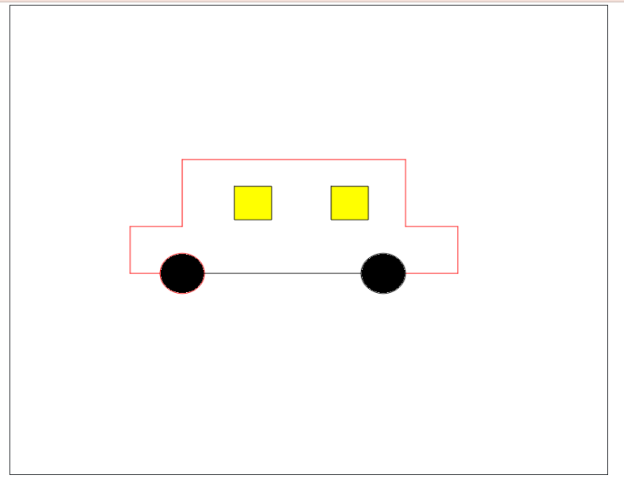

car
TO car cs pu setxy 130 -50 pd rt 90 fd 70 lt 90 fd 70 lt 90 fd 70 rt 90 fd 100 lt 90 fd 300 lt 90 fd 100 rt 90 fd 70 lt 90 fd 70 lt 90 fd 40 pu fd 30 pd wheel 30 "black fd 240 pu fd 30 pd wheel 30 "black pu setxy 30 80 pd windo 50 "yellow setcolor "black pu setx -100 pd windo 50 "yellow setcolor "black ht END
TO windo :size :color filled :color [repeat 4 [fd :size rt 90]] END
CLEARSCREEN

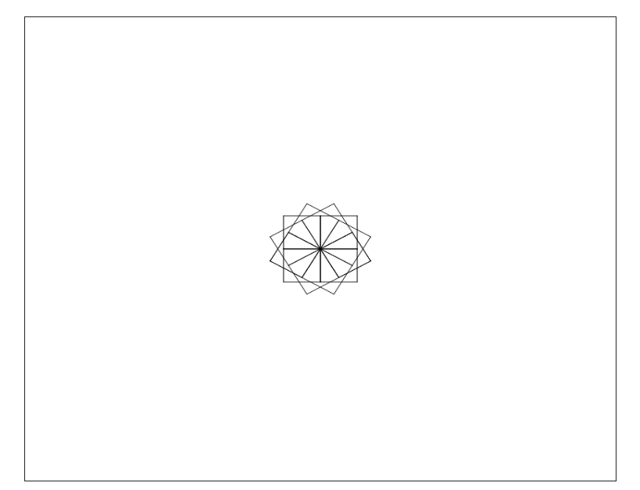

REPEAT 4 [FD 50 RT 90]
lt 30
REPEAT 4 [FD 50 RT 90]
lt 30
REPEAT 4 [FD 50 RT 90]
lt 30
REPEAT 4 [FD 50 RT 90]
lt 30
REPEAT 4 [FD 50 RT 90]
lt 30
REPEAT 4 [FD 50 RT 90]
lt 30
REPEAT 4 [FD 50 RT 90]
lt 30
REPEAT 4 [FD 50 RT 90]
lt 30
REPEAT 4 [FD 50 RT 90]
lt 30
REPEAT 4 [FD 50 RT 90]
lt 30
REPEAT 4 [FD 50 RT 90]
lt 30
REPEAT 4 [FD 50 RT 90]
CLEARSCREEN

Students can doodle different shapes of math using Turtle logo software. This helps them to analyse the properties of different shapes. Also this is an activity with freestyle with their own imaginations flying with different flares.

